1 Exotic Nuclear Molecules, Clusters and Bands

Nuclear Molecular Analogues

The access to radioactive ion-beam facilities, recently opened to the UK Nuclear Structure community, has also opened a new realm of nuclear phenomena to experimental study. These include, most prominently, nuclei with neutron-halos or other unusual structures. Nuclear-molecular-analogue states fall into this latter category. This classification refers to those nuclei that possess particular states whose shape and structure bear a striking resemblance to that of simple atomic molecules such as H₂ and O₂. These atoms are covalently bound by virtue of the exchange interaction involving the valence electrons. It has recently been suggested that the covalent bond may also be found on the nuclear scale. For example, the considerable binding energy of the ⁴He nucleus results in the 2×⁴He system, ⁸Be, being unbound.
Interestingly, the addition of a single neutron to the unstable ⁸Be nucleus produces the stable ⁹Be nucleus. The addition of a proton to form ⁹B fails to produce a bound ground state due to the further Coulomb repulsion. The nuclear potential that results from the underpinning α+α cluster structure should also be two-centred in form. Indeed, detailed Antisymmetrized Molecular Dynamics (AMD) calculations of the structure of ⁹Be also reveal the prevailing two-centred structure. The single-particle orbits in which the final unpaired neutron resides, are thus not those of the spherical shell model but the deformed or two-centre shell model. An examination of the low-lying states of this nucleus shows rotational bands, that are built on K=3/2⁻ and 1/2⁺ configurations, with moments of inertia consistent with the underlying two-centred potential. These nuclear orbits are the analogues of the atomic π- and σ-molecular bonds, and are revealed in the densities associated with the single-particle wave-functions. The introduction of a further neutron into these molecular type orbits produces states in ¹⁰Be again molecular in nature, with large deformation. However, these states are not related to the ground state but lie at E_{x}~6 MeV. This fascinating behaviour should be mirrored in the sequence of nuclei resulting from the accrual of protons to ⁸Be, namely ⁹B and ¹⁰C. However, in the case of ¹⁰C the structure in the proximity of the ¹⁰Be molecular-analogue states is poorly known.

Stemming from the α+α molecular building block it is possible to hypothesise that a whole sequence of valence particles may be added to produce increasingly complex molecular configurations. Indeed, the ¹¹Be J^{π}=1/2⁺ ground state would appear to be formed from a neutron in the σ-molecular orbit. This does not contradict the observation that this last neutron forms a halo around the ¹⁰Be core, but that the molecular-orbit is highly delocalised by the absence of Coulomb and centrifugal barriers. Antisymmeterized Molecular Dynamics calculations for the Be isotopes would support this interpretation. Further, it has also been speculated that molecular-analogue structures will be found in more complex systems based on larger sequences of α-particles, e.g. α+α+α chains. This remarkable behaviour in these light nuclei is far from understood, and the confirmation of these ideas presents a considerable experimental challenge. In the first instance, as is the case for ¹⁰C, little is known of the spectroscopy of many of these nuclei as excited states, let alone spins, are unmeasured. Detailed spectroscopic measurements using a combination of transfer and breakup reaction techniques can uncover the structure of

⁹Be

Figure 1. The proposed structure and excitation energies of Be isotopes and their location with respect to the decay thresholds.

these nuclei in the regions proposed to hold the molecular configurations. Breakup reactions tend to be a particularly powerful spectroscopic tool. Through the selection of particular decay channels, breakup reactions tend to enhance states with configurational overlaps with the decay products. This reduces experimental backgrounds, particularly if the states lie at high excitation energies. Moreover, angular correlation techniques may produce spin assignments, and decay cross-section measurements partial widths. In fact, the breakup reaction combines a measurement of all the key observables that may be used to characterise a state. Indeed, breakup reactions have been exploited, with considerable success, to expose the cluster structure of many light nuclei.

Recently, it has been demonstrated that this reaction technique is ideally suited to the environment of fragmentation beams produced by the GANIL radioactive ion-beam facility. Fragmentation beams are extremely poorly suited to the requirements of conventional charged particle spectroscopy methods, due to the poor beam energy and angular resolution. On the other hand, the effect of the beam energy spread and angular divergence cancel to a large extent in breakup measurements via the detection of decay products and the conversion to the decay centre-of-mass reference frame. In this case the uncertainties in the beam, that contribute equally to all decay products, counterbalance. This was aptly demonstrated in our recent measurement of the breakup of the nucleus ¹²Be into two ⁶He nuclei. ¹²Be is predicted to possess an α+4n+α molecular structure, and breakup measurements revealed a number of states which decayed into ⁶He+⁶He with possibly a rotational interdependence. In this instance the beam energy spread was 18 MeV and the reconstructed ¹²Be excitation energy resolution 700 keV, a point emphasising the benefits of the breakup method.
The quest would be the understanding of the nature of these molecular structures, the changes in the underlying nuclear structure which produce them and the linking of these effects to other structural phenomena, e.g. halos. The Charissa collaboration has pioneered most of the experimental and analysis techniques and is one of the foremost groups world-wide in this field. This puts us in a unique position to address this exciting area of research.

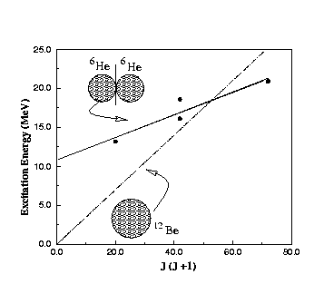
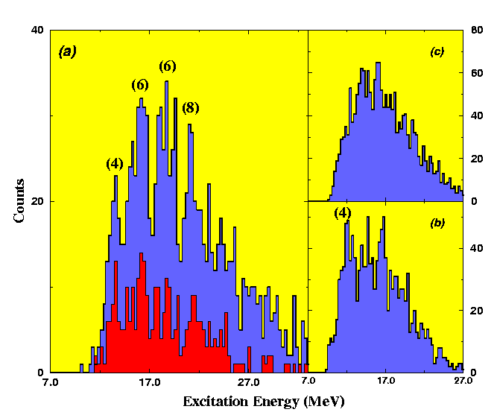

Figure 2. The excitation energy spectrum for ¹²Be breakup into two helium clusters (left). (a) ¹²Be->⁶He+⁶He from a ¹²C target (red) ¹²Be->⁶He+⁶He from proton and ¹²C targets (blue), (b) ¹²Be->⁴He+⁸He from a ¹²C target and (c) ¹²Be->⁴He+⁸He from a proton target. Energy-spin systematics of the observed states compared with that extracted for the ¹²Be ground state (right).

Based upon the above observations, it is possible to speculate that other atomic phenomena might also have nuclear analogues. For example, the NH₃ molecule possesses an unusual low frequency vibrational mode (originally used as an atomic clock) corresponding to the tunnelling of the Nitrogen atom through the barrier formed by the triangular arrangement of the H-ions. The resulting potential characterising the inversion of the molecule is also two-centred in nature. The ¹²C ground state has a pronounced triangular structure composed of three α-particles. Thus, it is possible that the addition of a further nucleon to form either ¹³N or ¹³C would form a nuclear analogue of the NH₃ molecule, with the vibrational mode corresponding to the periodic tunnelling of the valence neutron or proton through the barrier presented by the ring of α-particles. Interestingly, the issue of particles tunnelling through a potential barrier is also important for the future generation of solid-state devices, where the tunnelling of a single electron through a manufactured barrier may be used to transmit electronic information. As with the ammonia molecule an experimental signature for this molecular-like behaviour would be a strong dipole transition between same spin states, but with opposite parity. Interestingly, there would appear to be a number of states in ¹³N and ¹³C that satisfy this criterion, but the interaction between the configurations associated with the two potentials would appear to be stronger as a consequence of the larger tunnelling probability which may dilute the vibrational character of the states. Thus this would require a detailed investigation to confirm this oscillatory behaviour. Such experiments may employ joint particle-gamma detection techniques to study the nature of the states.

α-Cluster Analogue States
The molecular analogue states, described above, owe their origins to the underlying α-cluster structure. In the same way, echoes of α-clustering may be found in non-alpha-conjugate nuclei. For example, it is possible to envisage cluster structures composed of ³He or ³H components rather than α-particles. Considerable experimental and theoretical effort has been devoted to the issue of α-clustering in the nuclei ⁸Be, ¹²C, ¹⁶O, ²⁰Ne, ²⁴Mg, etc.., and a reasonable understanding of the phenomenon has been reached. The underlying principles are the stability of the α-particle and symmetries of the nuclear potential that produce shell structures in the single-particle energy level scheme at deformations which coincide with cluster arrangements. There are, however, prominent examples of clustering in nuclei that do not comprise of simply α-particles. For example, the two lithium isotopes ⁶Li and ⁷Li have a strong d+α and t+α structure and their mirrors, ⁶Be and ⁷Be, may be identified with 2p+α and ³He+α structures. These nuclei are of course examples of two centred clusters and have a two centred structure similar to ⁸Be. It

Figure 3. Possible vibrational modes of ¹³C and ¹³N.
is interesting to pose the question if this cluster replacement is a universal phenomenon. One of the most fascinating examples may be found in the group of nuclei ¹⁴C, ¹⁴O, ¹⁴N and ¹⁶O. The low-lying states of the three A=14 nuclei are surprisingly similar to those in ¹⁶O. In fact, the ¹⁶O rotational band built on the 0⁺_{1,} Ex=6.05 MeV, state is almost exactly mimicked by similar bands in ¹⁴C, ¹⁴O and ¹⁴N, giving rise to the concept of identical bands. The idea that seemingly these nuclei are unaffected by the α-cluster substitutes 2n, 2p and d is remarkable. The fact that the deformation of these nuclei, as measured by the moment of inertia of the bands, is unchanged from that ¹⁶O indicates that cluster substitution occurs in more complex systems. There is an alternative possibility, in which this behaviour can be described in terms of similar particle-hole excitations and are not in fact rotationally linked at all. In order to answer this question we would propose to measure the strength of the linking transitions between the states shown in Figure 4 as being rotationally linked, using particle-gamma detection techniques. This is not an isolated example, similar observations are possible for A=18 isobaric analogue states corresponding to two nucleon removal from ²⁰Ne.
The Antisymmeterised Molecular Dynamics calculations of Kanada En’yo et al. of the structure of isotopic chains of, for example, carbon, lithium, boron and beryllium nuclei also show that clustering is resilient against the splitting of the inert α-particle. It is proposed to investigate the underlying symmetries that buttress the nucleus against radical structural changes when the stability of the α-particle is breached. Systematic measurements using transfer breakup reaction studies, in which cluster structures are populated through transfer and then breakup proceeds to the cluster partition. As with the molecular analogue states, the strongest tests of the resilience of clustering will be found at the limits of stability and consequently studies using radioactive beams will be required.

Figure 4. Identical bands in ¹⁶O, ¹⁴O, ¹⁴N and ¹⁴C

Experimental Details
It is proposed to combine the attributes of both stable and radioactive beam facilities to study the range of phenomena described above. These two types of experimental facility provide two complementary perspectives from which measurements may be performed. Stable beam facilities provide the possibility of tracking the molecular/cluster phenomena from their origins close to the line of stability, building a detailed picture of the underlying fundamental nuclear properties, towards increasingly exotic structures. However, the limitations of stable beams are quickly reached when reactions requiring in excess of two neutrons/protons to be transferred. In this instance, the reaction cross-sections plummet, Q-values become negative in the extreme and backgrounds overwhelm the reaction of interest. On the other hand, radioactive beams often can provide direct access to the nucleus of interest in the form of a beam, and as a consequence backgrounds are significantly diminished. The weaker beam intensities of the radioactive beams can be compensated for by thicker targets, which tend to have a reduced affect on reaction products for breakup reactions producing light products which are the prime interest of the systems described above.
Our present studies have involved a measurement, at the GANIL radioactive ion-beam facility, of the molecular structure of ¹²Be, via the ⁶He+⁶He breakup reaction. This is to be followed by a search for similar structures in the nuclei ¹⁶⁻¹⁸C, again using breakup techniques (an approved experiment that will run in mid 1999). It is foreseen that the advent of SPIRAL will enhance the range of possible experiments. The reduced beam energy and increased beam energy and angular resolution will permit more precise measurements to be undertaken, in turn improving both the resolution with which we can reconstruct the reaction process and the selectivity of the experimental technique. There is particular interest in the acceleration of neon isotopes, which will carry the studies forward into more complex molecular systems. At the same time, GANIL fragmentation beams will provide access to the limits of the molecular isobaric chains, e.g. it would be interesting to observe if ⁶Be+⁶Be clusters exist in ¹²O, the counterpart to ¹²Be. The library of charged particle detection techniques that the Charissa collaboration has compiled, for example, strip-detectors, CsI-scintillators, gas-ionisation chambers and sheet two-dimensional position-sensitive detectors, implies that the detection system can be tailored to each experiment. This latter facility is crucial.

The omission, at present, is a purpose built reaction chamber, at GANIL, in which to house them. We plan to design and build a scattering chamber to be sited at the end of the LISE3 spectrometer. In fact, groups from GANIL and LPC are investing in an additional section of beam line and magnets, at the end of which the proposed chamber would be sited. The chamber would contain a number of movable arms for the mounting of the detection systems, with variable target positioning and, significantly, thin walls. This latter feature ensures that the charged particle detectors may be combined with neutron detectors, external to the vacuum vessel. It is recognised that the experimental excursion towards neutron-rich nuclei, will ultimately require the detection of neutrons in coincidence with charged particles. The combination of these detection facilities will provide a powerful system for spectroscopic measurements of neutron rich-nuclei, via breakup reactions. In fact, the group has been active in a number of studies that are the precursor of the system described. The DEMON array of 100 neutron detectors has been employed in the study of the breakup of the halo-nuclei ¹⁴Be and ¹⁹C, where neutrons were detected in coincidence with charged particles in a simple charged particle detection system. The Charissa group is also developing an array of neutron detectors that will be used in conjunction with charged particle detectors in the study of the decay of neutron-rich nuclei produced at the ANU stable beam facility.

The considerable flexibility of the charged particle detection systems of course must be matched by the capacity of the data acquisition system. At the ANU the MEGHA data acquisition system can record 640 reaction parameters (320 energies and 320 times). The data acquisition system which has been used at GANIL is presently much more modest, with a capacity of approximately 128 channels. In conjunction with LPC, Caen, we are embarking on the construction of a new data acquisition system. This will be VME centred, interfacing with digital conversion units in either CAMAC or VXI. LPC are responsible for the construction of the VME components, whilst the Charissa collaboration are committed to providing amplifiers and ADCs. At present we have sufficient units to instrument a 128 (?) channel system, but to cope the number of reaction parameters generated by the experiments using, for example, strip detectors at GANIL, it is essential to upgrade this capacity to 256 channels.

