# Calibrating the LMK3200 clock devices on the AIDA FEE64

If the System Wide checks reports a clock fault in one of the FEE modules.

Open a browser window to the faulty FEE using http://< FEE IP address>:8015/AIDA/Aida.tml

In the opened Control window select Clock Control

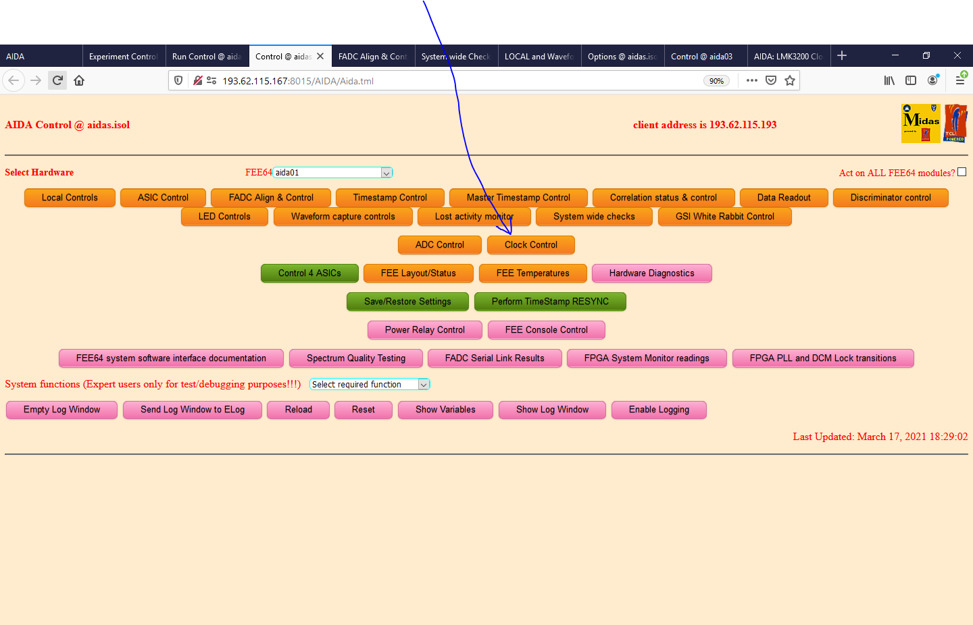

This opens the following window

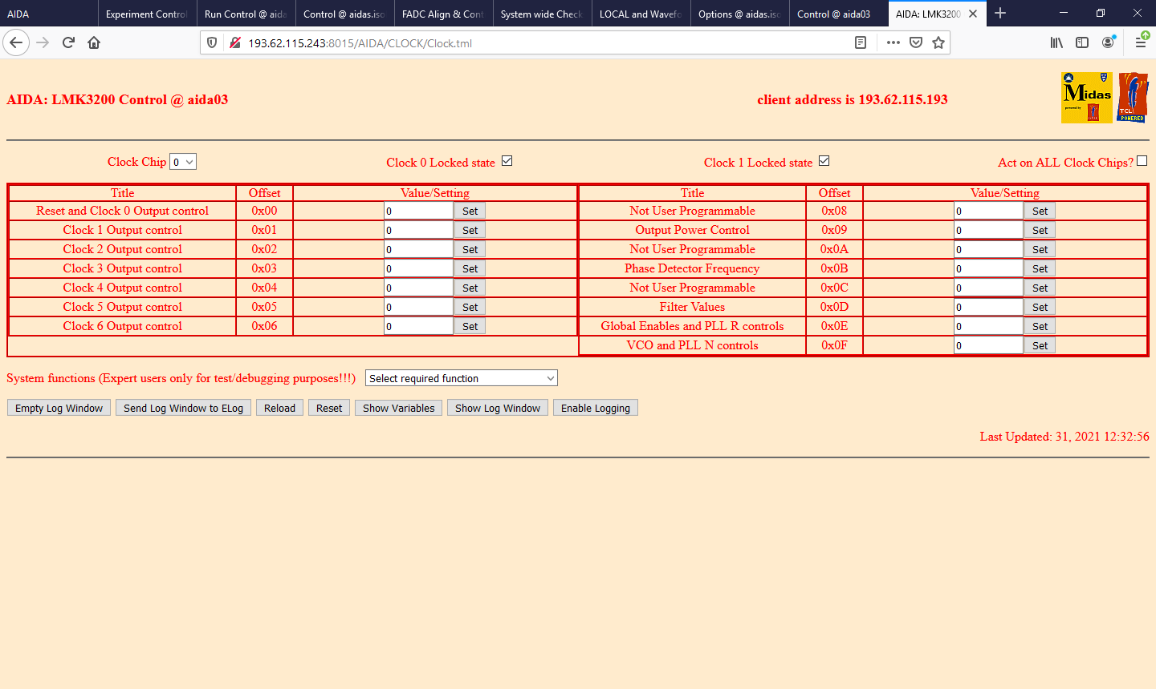

From the System Functions menu select “Register default settings”

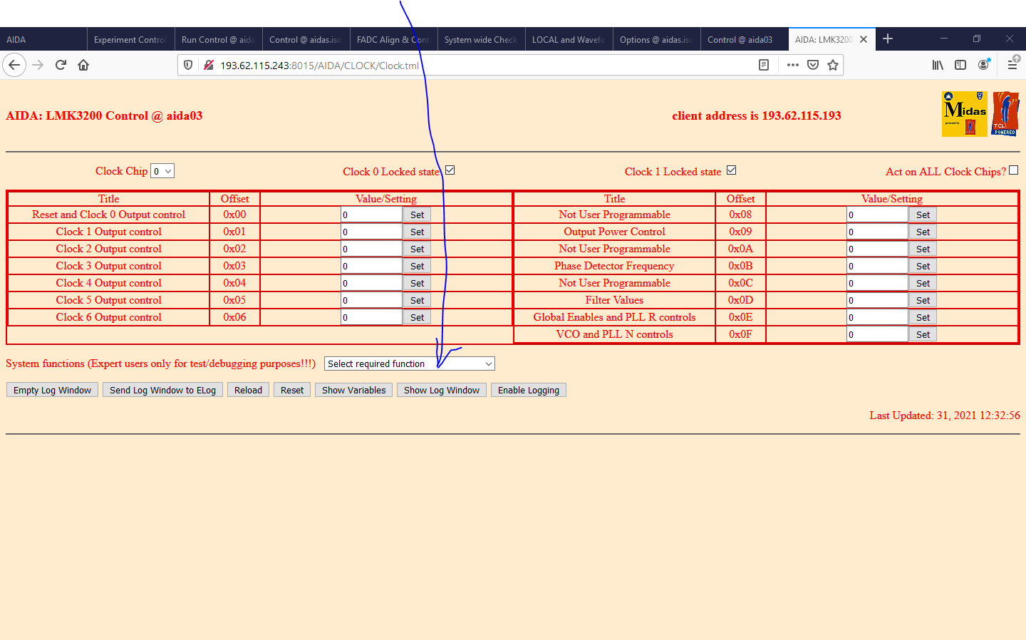

Select “Act on all Clock Chips” in the top right hand corner.

From the “System functions” select Calibrate LMK3200 for incoming clock”

This takes a few seconds and reports the bit sequences sent to the LMK3200 registers; disregard.

Check that the two “Clock # locked state” tick boxes are ticked.

If this doesn’t work then operate a RESET/SETUP of this FEE from the RunControl window.

If this still doesn’t work then …. Check the HDMI cable and the MACB structure.